**Soprano Rosanne G. Hargrave**, former artist member and past president of the Monday Musical Club of Albany, has studied voice with Karen Ranung and coaches with Michael Clement. She performs music from Oratorio and Opera to Jazz and Broadway.  Rose has sung as cantor/soloist with St. Margaret Mary’s Church, All Saints Catholic Church and The New York Catholic Chorale. She has performed roles with Opera Excelsior, Family Players of Northeastern New York, and collaborated with comic baritone, Mark Levy, in a cabaret entitled “Men are from Mars, Women are from Venus…The Musicale” (2005).  Rose is featured vocalist on the CD entitled, “Mis Suenos de Tango” (2006) with Spiral Ensemble, and a more recent recording, “Armenian Genocide Centennial Memorial Concert” (2015) with Andrew Krystopolski (piano). Past musical engagements have included The Mendelssohn Club, Troy Savings Bank Music Hall, Proctor’s Theater (Schenectady), Caffe Lena (Saratoga), the Albany Tulip Festival ,70 Beekman Street Art Gallery (Saratoga), Mohonk Mountain House Resort (New Paltz), the Hyde Collection (Glens Falls), and Saratoga Racetrack. She enjoys collaborating with other artists, and performs benefit concerts throughout the Capital region. Rose can be reached at [rosehargrave@nycap.rr.com](mailto:rosehargrave@nycap.rr.com). Website: [www.rosehargrave.com](http://www.rosehargrave.com).

**Pianist Michael Clement** has studied at the Eastman School of Music, the Chautauqua Institute, the University of Arizona and the University of Southern California.  He was pianist for the Tucson Symphony, Assistant Conductor for Long Beach Opera and director of the Opera Workshop at California State University at Long Beach and has served on the staff of Florentine Opera of Milwaukee. Locally, Michael has served as the Music Director for Opera Excelsior, and staff accompanist for Skidmore College and the College of Saint Rose. He has appeared as soloist with the Bellflower Symphony, CETA Symphony, and Japanese Philharmonic of Los Angeles.  He currently serves on the musical staff of Lake George Opera, now Opera Saratoga, and works with other emerging opera companies in the Capital district.  He is also Minister of Music at Emmanuel Baptist Church in Albany, and pianist for the Mendelssohn Club of Albany. He regularly presents concerts at Emmanuel and in recitals around the Capital District and elsewhere, as a soloist and as an in-demand accompanist and vocal coach. He maintains an active teaching studio in Niskayuna and can be reached at emclem88@outlook.com.

**A Place for Us!**

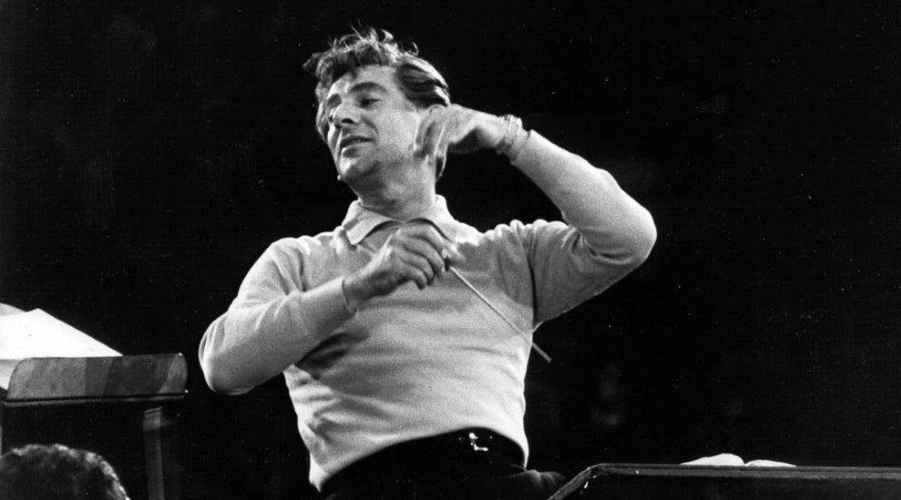

**A Journey of Belonging with Music by Leonard Bernstein**

**Rosanne Hargrave Soprano**

**Michael Clement Piano**

**Sunday, November 17th , 2024 @ 2:00 pm**

**A Little Sunday Music**